Client Side Scripting

JavaScript is most commonly used as a client side scripting language.

Using HTML we can only design a web page but you cannot run any logic on web browser like addition of two numbers, check any condition, looping statements (for, while), decision making statement (if-else) at client side.

All these are not possible using HTML. So, to perform all these tasks at client side you need to use JavaScript.

Features of JavaScript:

Inheritance does not support in JavaScript, so it is called object based oriented language.

JavaScript was developed by Netscape (company name) & initially called live script.

Later Microsoft developed & adds some features live script then it is called “Jscript”.

Jscript is nothing but Java script. We cannot create own classes in java script.

Java script is designed to add interactivity to HTML pages. It is usually embedded directly into html pages.

Java script is mainly useful to improve designs of WebPages, validate form data at client side, detects (find) visitor‘s browsers, create and use to cookies, and much more.

Java script is also called light weight programming language, because Java script is return with very simple syntax. Java script is containing executable code.

Java script is also called interpreted language, because script code can be executed without preliminary compilation.

JavaScript is case sensitive.

Most of the javascript control statements syntax is same as syntax of control statements in C language.

An important part of JavaScript is the ability to create new functions within scripts.

Declare a function in JavaScript using function keyword.

Creating a java script: -

html script tag is used to script code inside the html page.

<script > </script>

The script is containing 2 attributes. They are

1) Language attribute:-

It represents name of scripting language such as JavaScript, VbScript.

<script language=”JavaScript”>

2) Type attribute: -

It indicates MIME (multi purpose internet mail extension) type of scripting code. It sets to an alpha-numeric MIME type of code.

<script type=”text / JavaScript”>

Script code can be placed in both head & body section of html page.

Eg:

<html>

<head>

<script language="JavaScript">

document.write("hai my name is Krishna")

</script>

</head>

<body text="red">

<script language="JavaScript">

document.write("hai my name is Ram")

</script>

</body>

</html>

Output:

hai my name is Krishna

hai my name is Ram

document. write is the proper name of object.

Creating external script: -

some times you might want to run same script on several pages without having to write the script on each page.

To simplify this, write external script & save .js extension.

To use external script specify .js file in src attribute of script tag.

Eg: external.js

document.write("this is external script code 1 "+"<br>");

document.write("this is external script code 2 "+"<br>");

document.write("this is external script code 3 "+"<br>");

document.write("this is external script code 4 ");

external.html

<HTML>

<BODY>

<script language="JavaScript">

document.write("this is document code 1 "+"<br>");

document.write("this is document code 2 "+"<br>");

</script>

<script src="external.js"> </script>

</BODY> </HTML>

JavaScript syntax rules: -

JavaScript is case sensitive language.

In this upper case, lower case letters are differentiated (not same).
Ex:- a=20; A=20;

Those the variable name “a‟ is different from the variable named “A‟.
Ex: - myf( ) // correct myF( ) // incorrect

→ ; is optional in general JavaScript.
Ex:- a=20 //valid
b=30 //valid
A=10; b=40; // valid
However it is required when you put multiple statements in the same line.

→ JavaScript ignore white space. In java script white space, tag space & empty lines are not preserved.
→ To display special symbols we use \.

Comment lines: - comments lines are not executable.

// single line comment

/* this is multi line comment */

- Declaring variable: - Variable is a memory location where data can be stored. In java script variables with any type of data are declared by using the keyword “var”. All keywords are small letters only.

Var a; a=20;
Var str; str= “Sunil”;
Var c; c=‟a‟;

Var d; d=30.7;
But the keyword is not mandatory when declare of the variable. c; → not valid. In this solution “var” keyword must be declared.

→During the script, we can change value of variable as well as type of value of variable.
Ex: - a=20; a=30.7;

- JavaScript functions: - In java script, functions are created with the keyword “function” as shown below

Syntax: //function function funname( )
{

--------
}
Generally we can place script containing function head section of web page. There are 2 ways to call the function.

Direct call function
- Events handlers to call the function dynamically.

Direct call function:

We can pass data to function as argument but that data will be available inside the function.

Ex: -
<HTML>
<HEAD>
<TITLE> Function direct call</TITLE>
<script language="JavaScript">
Function add(x,y)
{
z=x+y return z
}
</script>

</HEAD>
<BODY>
<script>
var r=add(30,60) document.write("addition is :"+r);
</script>
</BODY>
</HTML>

O/P: - addition is :90

To add dynamical effects, javascript provide a list of events that call function dynamically. Here each event is one attribute that always specified in html tags.

attrname=”attrval”

eventName=”funname()”
Ex: -
<HTML>
<HEAD>
<TITLE> Function dynamically</TITLE>
<script language="JavaScript"> function add( )
{ x=20 y=30
z=x+y
document.write("addition is :"+z);
}
</script>
</HEAD>
<BODY> to call function:
<input type="button" value="click here" onclick="add( )">

</script>
</BODY>
</HTML>
O/P: - to call function: addition is :90

EVENTHANDLERS:

Events are not case sensitive.
Java script events: -

Attribute The event occurs when… onclick mouse click an object ondblclick mouse double clicks onmouseover a mouse cursor on touch here onmousedown a mouse button is pressed
onmousemove the mouse is moved
onmouseout the mouse is moved out anelement onmouseup a mouse button is released

onkeydown a keyboard key is pressed
onkeypress a keyboard key is pressed or held down onkeyup a keyboard key is released

onfocus an elements get focus
onblur an element loses focus

onchange the content of a field change
onselect text is selected

onload a page or an image is finished loading
onunload the user exist the page

onerror an error occurs when loading a document or animage onabort loading an image is interrupted
onresize a window or frame is resized onreset the reset button is pressed onsubmit the submit button is clicked

Ex: -
</b>
<br>
<b onmouseover="add( )"> to call function touch here :
</b>
<br>
<b ondblclick="add( )">
to call function double click here :
</b>
<br>
<b onmousemove="add( )">
to call function cursor move here :
</b>
<br>
<b onmouseup="add( )">
to call function cursor up here :
</b>
<HTML>
<HEAD>
<TITLE> Mouse Events </TITLE>
<script language="JavaScript"> function add()
{ a=55 b=45
c=a+b
document.write("addition is :"+c)
}
</script>
</HEAD>
<BODY>
<b onclick="add( )">
to call function click here :

O/P: -
<br>
<b onmouseout="add( )">
to call function cursor out here :
</b>
</BODY>
</HTML>
to call function click here : to call function touch here :
to call function double click here : addition is :100
to call function cursor move here : to call function cursor up here :
to call function cursor out here :

Program: -
<HTML>
<HEAD>
<TITLE> display student name </TITLE>
<script language="JavaScript"> function disp( )
{
// access from data
var name=window.document.student.sname.value
// (or) var name=window.document.getElementById("snameid").value
//checking name if(name=""||!isNaN(name)||!isNaN(name.charAt(0)))
window.alert("sname you entered isinvalid")

else

}

document.write("sname you have entered is : "+name);

</script>
</HEAD>
<BODY>
<form name="student"> Enter Student name:
<input type="text" name="sname"id="snameid" value="enter" onblur="disp( )">
</form>
</BODY>
</HTML>

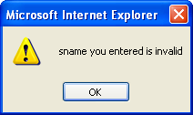
O/P: -
1
Enter Studentname:

Enter Studentname:
1
sname you have entered is : true

Popup boxes: - popup (arises) box is a small window that always shown before opening the page. The purpose of popup box is to write message, accept some thing from user. Java script provides 3 types of popup boxes. They are 1) alert 2) Confirm. 3) Prompt.

alert popup box :-

Alert box is a very frequently useful to send or write cautionary messages to end use alert box is created by alert method of window object as shown below.
Syntax: - window.alert (“message”);
When alert popup, the user has to click ok before continue browsing.

Ex: -
<html>
<head>
<title> alert box </title>
<script language="JavaScript"> function add( )
{ a=20 b=40
c=a+b
window.alert("This is for addition of 2 no's")
document.write("Result is: "+c)
}
</script>
</head>
<body onload="add( )">
</body>
</html>
O/P: -
Result is: 60

- confirm popupbox:-
This is useful to verify or accept some thing from user. It is created by confirm method of window object as shown below.
Syntax:- window.confirm(“message?”);

When the confirm box pop‘s up, user must click either ok or cancel buttons to proceed. If user clicks ok button it returns the boolean value true. If user clicks cancel button, it returns the boolean value false.
Ex: - |  |  |  |  | document.write("result is :"+c)
<HTML> |  |  |  |  | }
<HEAD> |  |  |  |  | Else
<TITLE> Confirm </TITLE> |  |  |  |  | {
<script> |  |  |  |  | document.write("you clicked cancel button")
function sub( ) |  |  |  |  | }
{ |  |  |  |  | }
a=50 |  |  |  |  | </script>
b=45 |  |  |  |  | </HEAD>
c=a-b |  |  |  |  | <BODY onload="sub( )">
x=window.confirm("Do you | want | to | see |  | to see the o/p in pop up box:
subtraction of numbers") |  |  |  |  | </BODY>
if(x==true) |  |  |  |  | </HTML>
{

O/P: -

WebTechnologies Page28

to see the o/p in pop up box:

result is :5

- Prompt popup box:- It is useful to accept data from keyboard at runtime. Prompt box is created by prompt method of window object.

window.prompt (“message”, “default text”);
When prompt dialog box arises user will have to click either ok button or cancel button after entering input data to proceed. If user click ok button it will return input value. If user click cancel button the value ―null‖ will be returned.

Ex: -

<HTML>
<HEAD>
<TITLE> Prompt </TITLE>
<script> function fact( )
{
var b=window.prompt("enter +ve integer
:","enter here") var c=parseInt(b) a=1 for(i=c;i>=1;i--)

O/P: -
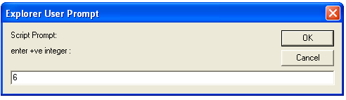

{
a=a*i
}
window.alert("factorial value :"+a)
}
</script>
</HEAD>
<BODY onload="fact( )">
</BODY>
</HTML>

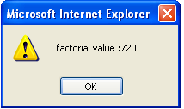

FORM VALIDATION:
When we create forms, providing form validation is useful to ensure that your customers enter valid and complete data. For example, you may want to ensure that someone inserts a valid e-mail address into a text box, or perhaps you want to ensure that someone fills in certain fields.
We can provide custom validation for your forms in two ways: server-side validation and client- side validation.

SERVER-SIDE VALIDATION:

- In the server-side validation, information is being sent to the server and validated using one of server-side languages.
- If the validation fails, the response is then sent back to the client, page that contains the web form is refreshed and a feedback is shown.
- This method is secure because it will work even if JavaScript is turned off in the browser and it can‘t be easily bypassed by malicious users.
- On the other hand, users have to fill in the information without getting a response until they submit the form. This results in a slow response from the server.
- The exception is validation using Ajax. Ajax calls to the server can validate as you type and provide immediate feedback.
- Validation in this context refers to validating rules such as username availability.
Server side validation is performed by a web server, after input has been sent to the server.

CLIENT-SIDE VALIDATION:

- Server-side validation is enough to have a successful and secure form validation. For better user experience, however, you might consider using client-side validation.
- This type of validation is done on the client using script languages such as JavaScript.
- By using script languages user‘s input can be validated as they type.
- This means a more responsive, visually rich validation.
- With client-side validation, form never gets submitted if validation fails. Validation is being handled in JavaScript methods that you create (or within frameworks/plugins) and users get immediate feedback if validation fails.
- Main drawback of client-side validation is that it relies on JavaScript. If users turn JavaScript off, they can easily bypass the validation. This is why validation should always be implemented on both the client and server. By combining server-side and client-side methods we can get the best of the two: fast response, more secure validation and better user experience.

- Client side validation is performed by a web browser, before input is sent to a web server.

Validation can be defined by many different methods, and deployed in many different ways.

Simple Example:
<html>
<head>
<title>FormValidation</title>
<script type="text/javascript">
<!--
// Form validation code will come here.
function validate()
{
var n = document.myForm.Name.value;
if( n == "" || (!isNaN(parseInt(n))) || n.length< 3 || n.length >= 8)
{
alert( "Please enter valid name and minimum length 3 characters and maximum length 8 characters !" );
document.myForm.Name.focus();
return false;
}
var emailID = document.myForm.EMail.value;
if( emailID == "" )
{
alert( "Please provide your Email!" );
document.myForm.EMail.focus() ;
return false;
}
atpos = emailID.indexOf("@");
dotpos = emailID.lastIndexOf(".");
if (atpos < 1 || ( dotpos - atpos < 2 ))
{
alert("Please enter correct email ID")
document.myForm.EMail.focus() ;
return false;
}
var z = document.myForm.Zip.value;
if(z == "" ||isNaN(z) || z.length != 6 )
{
alert( "Please provide a zip in the format #####." );
document.myForm.Zip.focus() ;
return false;
}
var c = document.myForm.Country.value;
if( c == "-1" )
{
alert( "Please provide your country!" );
return false;
}
return( true );
}
//-->
</script>
</head>
<bodybgcolor="blue">
<h1><p align="center">
<b>Application Form Validation Using JavaScript</b></p></h1>
<form action="reg.html" name="myForm" onsubmit="return(validate());">
<table cellspacing="5" cellpadding="5" align="center" border="5" width="438">
<tr>
<td align="right"><b>Name</b></td>
<td><input type="text" name="Name" size="50" /></td>
</tr>
<tr>
<td align="right"><b>EMail</b></td>
<td><input type="text" name="EMail" size="50" /></td>
</tr>
<tr>
<td align="right"><b>Zip Code</b></td>
<td><input type="text" name="Zip" size="50" /></td>
</tr>
<tr>
<td align="right" ><b>Country</b></td>
<td>
<select name="Country">
<option value="-1" selected>[choose yours]</option>
<option value="1">INDIA</option>
<option value="2">UK</option>
<option value="3">USA</option>
</select>
</td>
</tr>
<tr>
<td align="right"></td>
<td><input type="submit" value="Submit"
/></td>
</tr>
</font></table></form></body>
</html>

Output:
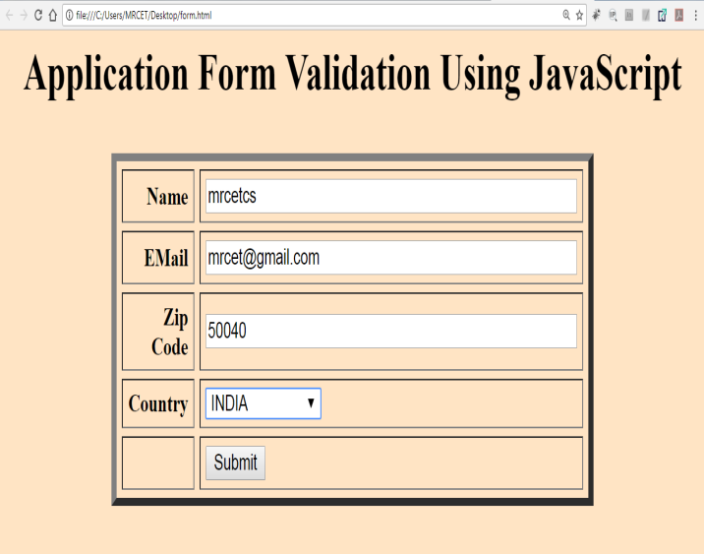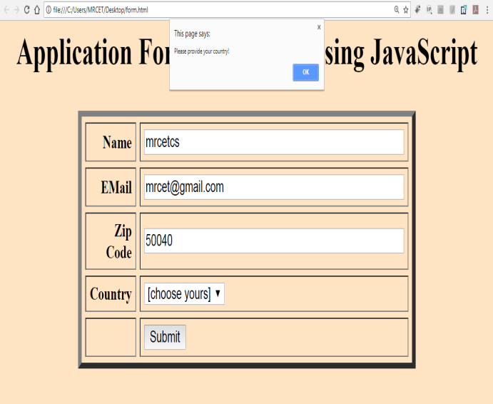
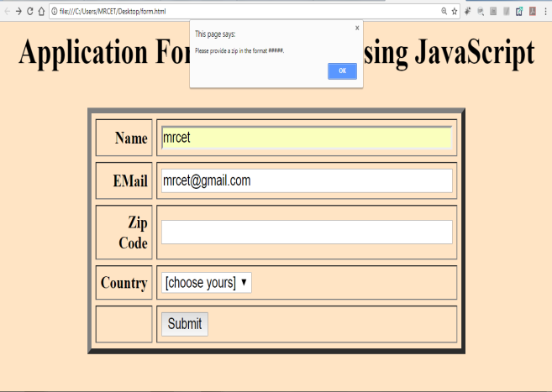

DOM Manipulation:

What is DOM?
- DOM → Document Object Model.
- It is a programming interface for web documents.
- It represents the HTML document as a tree structure, where each node is an object (elements, attributes, text).
- With JavaScript, we can access, modify, add, or delete elements from the DOM dynamically.

- Selecting Elements
- document.getElementById("id")
- document.getElementsByClassName("class")
- document.getElementsByTagName("tag")
- document.querySelector("selector") → returns first match
- document.querySelectorAll("selector") → returns all matches

Eg:
let heading = document.getElementById("title");
let items = document.querySelectorAll(".list-item");

2. Changing Content
- element.innerHTML → change HTML inside
- element.textContent → change only text

Eg:
heading.innerHTML = "Hello <em>World</em>";
heading.textContent = "Hello World";

  - Changing Styles

Eg:

heading.style.color = "blue";
heading.style.fontSize = "24px";

  - Attributes

    - getAttribute("attr")
    - setAttribute("attr", "value")
    - removeAttribute("attr")
Eg:

let link = document.querySelector("a");
link.setAttribute("href", "https://example.com");

  - Creating & Adding Elements

- document.createElement("tag")
  - appendChild()
  - prepend()
  - append()
  - insertBefore()
Eg:
let newItem = document.createElement("li");
newItem.textContent = "New List Item";
document.querySelector("ul").appendChild(newItem);

  - Removing Elements

let item = document.querySelector("li");
item.remove(); // modern way

JavaScript (ES6+ and Modern Features):

1. let and const
- let → Block-scoped variable, can be reassigned.
- const → Block-scoped, cannot be reassigned (but objects/arrays can be mutated).
- Avoids issues with var (function/global scope, hoisting).
Eg:
let x = 10;
x = 20; // ✅ Allowed

const y = 30;
y = 40; // ❌ Error

2. Destructuring

Extract values from arrays/objects into variables easily.

// Array
const arr = [1, 2, 3];
const [a, b] = arr; // a=1, b=2

// Object
const person = {name: "Ramya", age: 30};
const {name, age} = person;

3. Spread and Rest Operators (...)

- Spread → Expands arrays/objects.
- Rest → Collects remaining arguments.

// Spread
const nums = [1, 2, 3];
const newNums = [...nums, 4, 5]; // [1,2,3,4,5]

// Rest
function sum(...args) {
return args.reduce((a, b) => a + b, 0);
}
sum(1,2,3,4); // 10

4. Promises

Used for asynchronous operations.

const promise = new Promise((resolve, reject) => {
let success = true;
success ? resolve("Done") : reject("Error");
});

promise.then(res => console.log(res)).catch(err => console.log(err));

Why Do We Need Promises in JavaScript?

JavaScript is Single-Threaded
- JS runs on one main thread (event loop).
- If you run a long task (like API call, file read, DB query) synchronously, it blocks the page (UI freezes).

5. Async / Await

Cleaner way to handle promises.
- async makes a function return a Promise
- await makes a function wait for a Promise

async function fetchData() {
try {
let res = await fetch("https://jsonplaceholder.typicode.com/todos/1");
let data = await res.json();
console.log(data);
} catch (err) {
console.error(err);
}
}
fetchData();

6. Fetch API

Modern way to make HTTP requests.

fetch("https://jsonplaceholder.typicode.com/posts")
.then(res => res.json())
.then(data => console.log(data))
.catch(err => console.error(err));

7. Error Handling

- try...catch is used for exceptions.
- throw creates custom errors.

try {
let x = JSON.parse("wrong JSON");
} catch (err) {
console.error("Error:", err.message);
}

8. localStorage & sessionStorage

- localStorage → Persistent until manually cleared.
- sessionStorage → Cleared when browser tab is closed.

localStorage.setItem("name", "Ramya");
console.log(localStorage.getItem("name")); // "Ramya"
localStorage.removeItem("name");

9. Modular JavaScript (ES Modules)
- export and import are used.
// file: math.js
export function add(a, b)
{
return a + b;
}

// file: app.js
import { add } from './math.js';
console.log(add(2,3));

10. Built-in Objects
- Common: Math, Date, JSON, Array, String, Object.

console.log(Math.max(1, 5, 9)); // 9
console.log(new Date().toDateString());

11. Working with JSON
JSON = JavaScript Object Notation (used for APIs).

const obj = {name: "Ramya", age: 30};
const str = JSON.stringify(obj); // Object → String
const parsed = JSON.parse(str); // String → Object

12. Debugging & Developer Tools
- Use console.log, console.error, console.table.
- Browser DevTools → Inspect elements, Network tab, Debugger (breakpoints).
- debugger; keyword can pause execution.

function testDebug(x) {
debugger; // Execution stops here in DevTools
console.log(x);
}
testDebug(5);

Arrow Functions:

- Arrow functions are a shorter way to write functions introduced in ES6.
They make code cleaner and also behave differently with this.

Eg:

General Function Syntax:

function add(a, b) {
return a + b;
}

Using Arrow Functions:

const add = (a, b) => a + b;

- No function keyword.
- If there’s only one line, {} and return can be skipped.
- An arrow function is defined using the` =>`

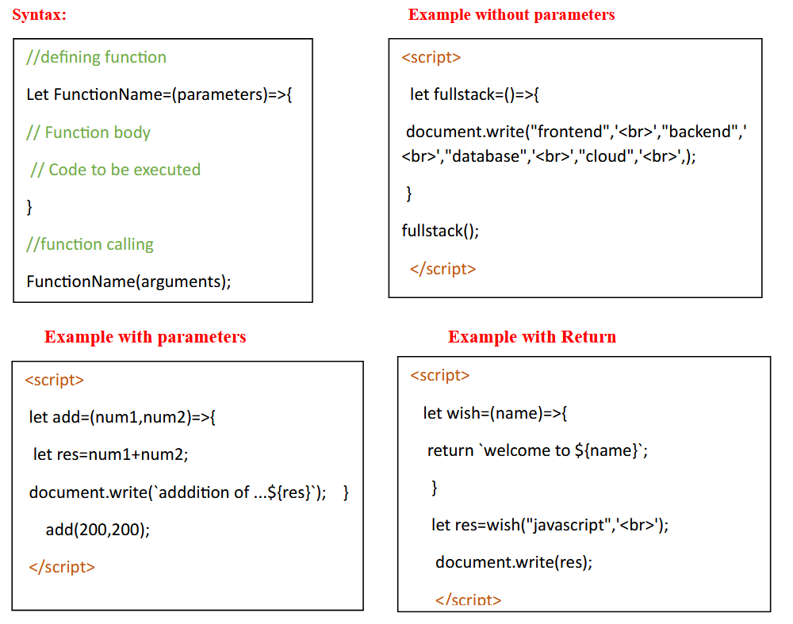

Call back Functions:

- Passing one function definition to other function parameter called as callback function.
- callback are used to make the api calls / connect to server /making asynchronous calls.

